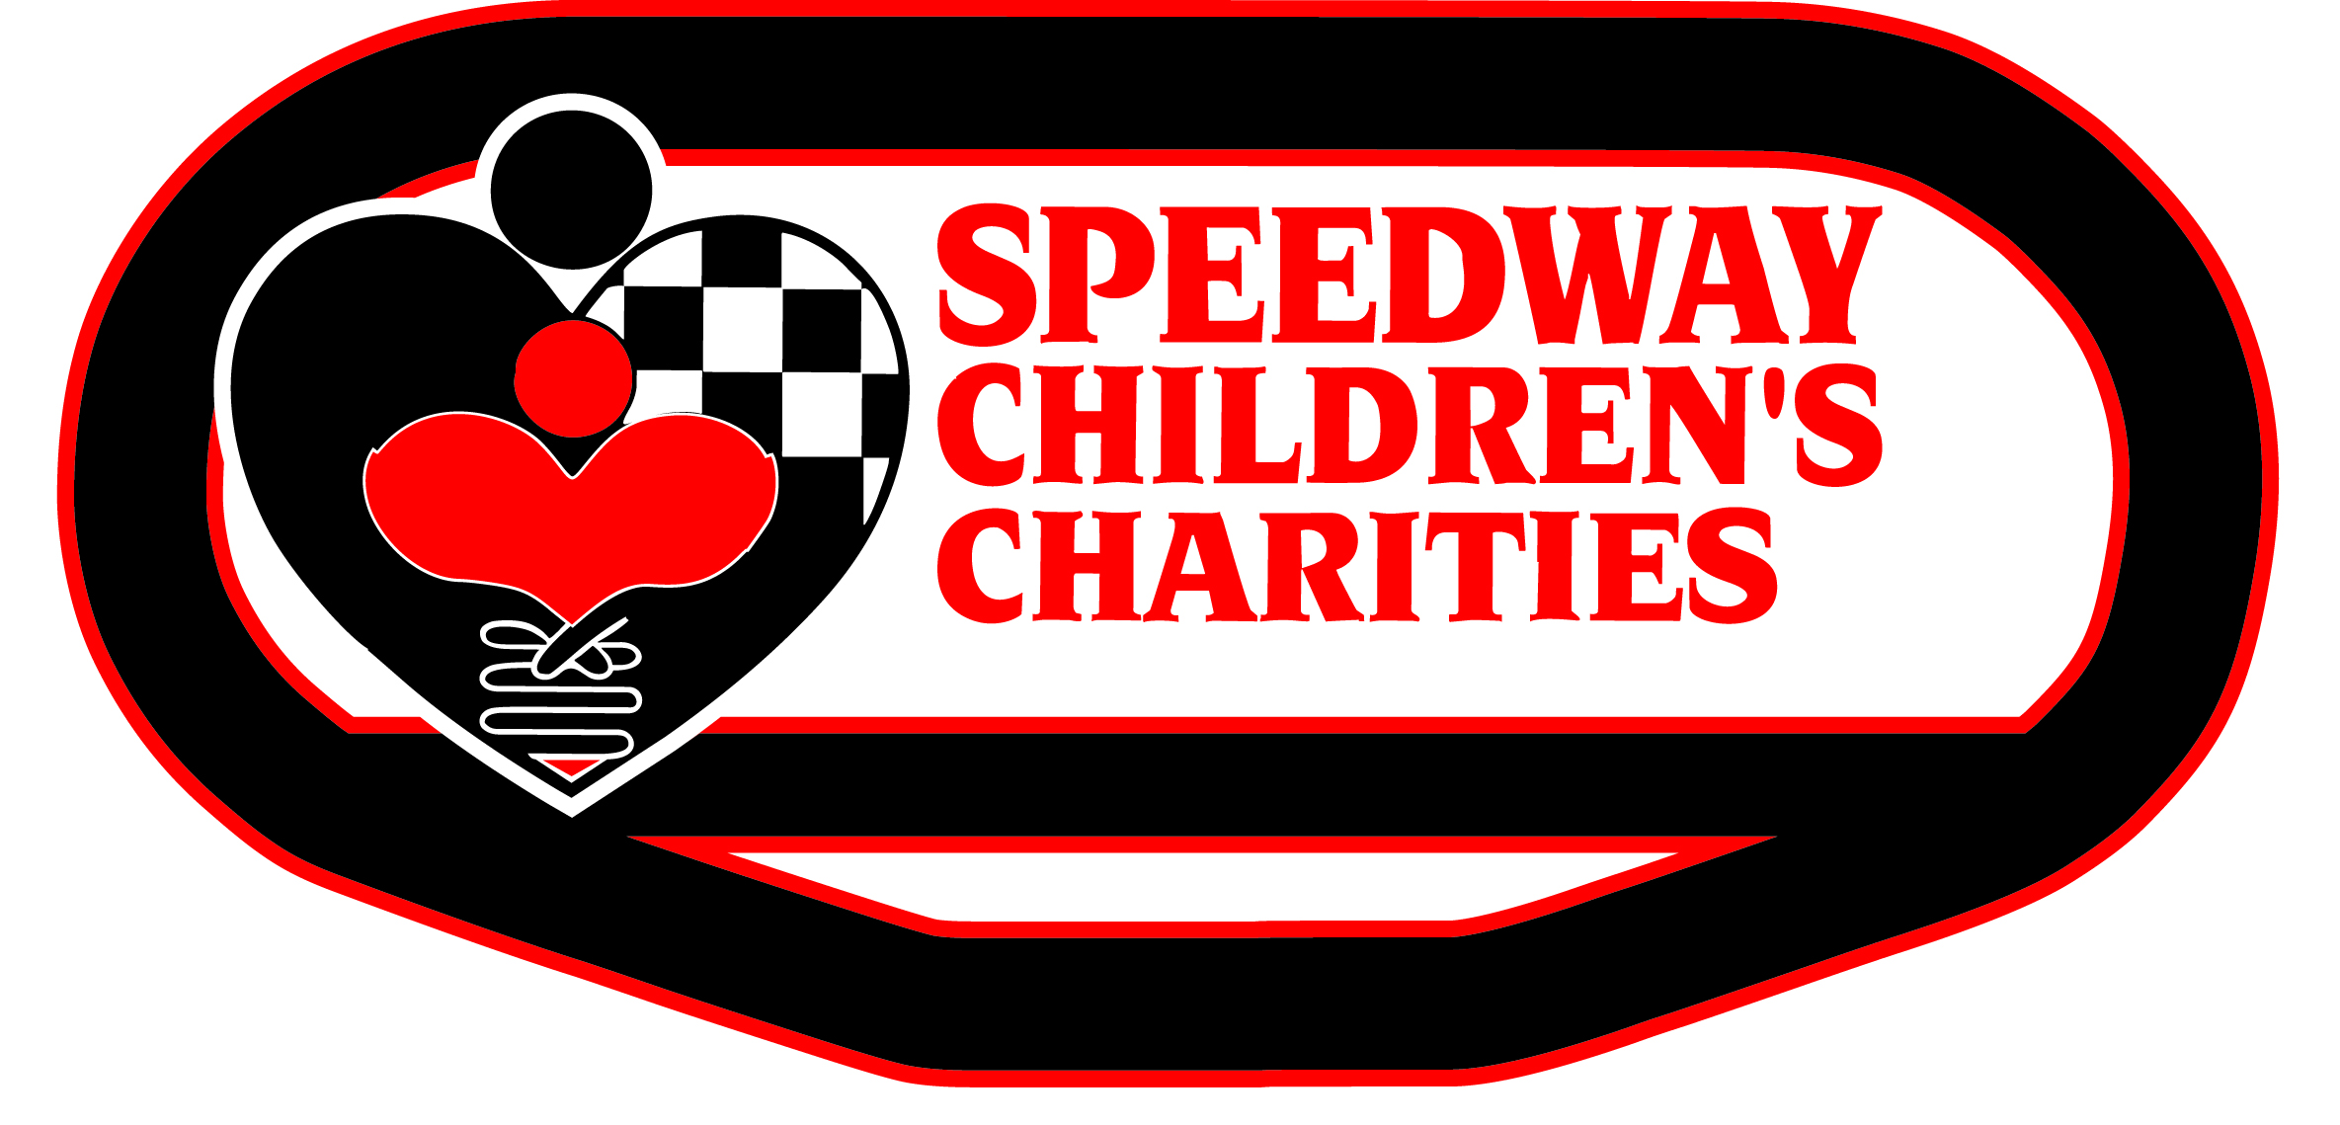

SCC Application Guidelines

A completed grant application MUST include one copy, as indicated below. Please use standard typeface, no smaller than 10-point font. Please supply all information, but attach only documentation requested. Information not requested will not be considered (i.e. video and audio tapes, yearbooks, catalogues, etc.)

Copy of the application must include:
- 1 copy of the completed SCC grant application
- 1 copy of your IRS 501(c)(3) verification
- 1 copy of your most recent IRS 990 (only one copy is required)
- 1 copy of your financials (prior fiscal year profit and loss statement, including operating budget and FY19/20 budget)
- 1 copy of your Board of Directors-including affiliations, Mission Statement and Organizational Chart

This copy should be three-hole punched and placed in a ½-inch black binder with dividers, as indicated. Documents are to be filed in the binder under the appropriate, labeled sections in the following order:
    - Grant Application
    - IRS 501(c)(3) verification
    - IRS 990
    - Finances
    - Board of Directors/Mission Statement/Organizational Chart

Please note:
    - The applicant should retain a copy of the application for his/her files.
- All inquiries regarding the grant application process should be submitted via email to cplattner@sonomaraceway.com. Return phone calls regarding grant applications may be delayed.

All applications must be received by Speedway Children’s Charities on or before
Tuesday, June 23, 2020 at 5 p.m.

If mailed, please send to:

Attn: Cheri Plattner
Sonoma Raceway
29355 Arnold Drive
Sonoma, CA 95476

Applications received after 5 p.m., June 23, 2020, will not be accepted!

