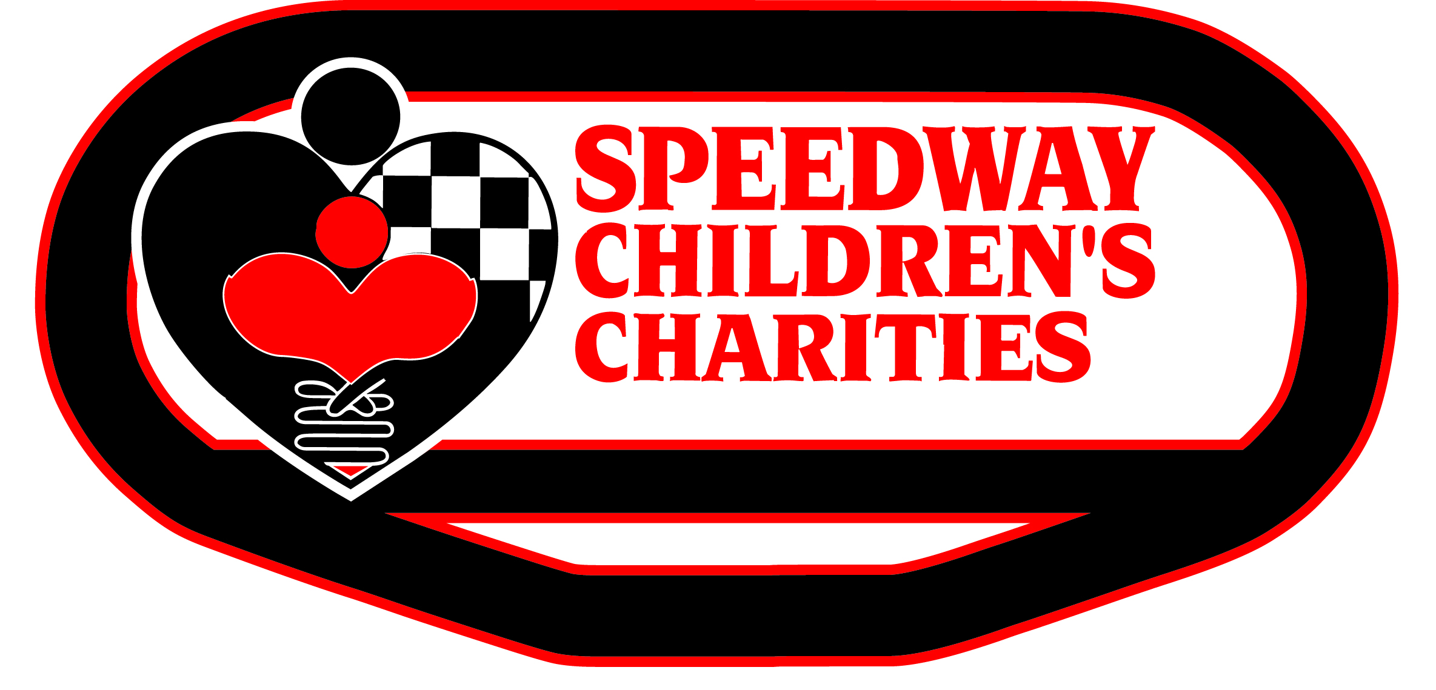

29355 Arnold Drive Sonoma, CA 95476 (707) 933-3950

Welcome to the 2020 Speedway Children’s Charities (SCC) grant application process.

Thank you for contacting the Sonoma chapter of SCC regarding funding for your program. Our organization is dedicated to caring for children in educational, financial, social and medical need to help them lead productive lives.

To clearly focus our efforts on Sonoma County youth in need, priority is given to programs that focus on:

- Education – after school, tutoring, education, books
- Critical Needs – food, shelter, clothing
- Financial – disaster relief, housing assistance
- Medical – medical, dental, therapy, camps for medical reasons
- Social – camps, music, art, dance, social clubs

Requests must be submitted using the SCC Grant Application, which is available online. If you would like to request a hard copy to be mailed to you, please contact me directly.

Only non-profit 501(c)(3) charities, which are tax exempt for federal (and state, if applicable) are eligible to apply. Grants will not be made to organizations that discriminate on the basis of race, color, sex, creed or national origin.

Due to the volume of requests, SCC is unable to grant every application. Please note: SCC does not fund first-year programs or organizations, capital campaigns, general operating costs or construction/remodeling projects. Applicants should understand that a declined proposal does not reflect on their organization; it is often a matter of funding limitations.

Charities that are awarded grants SHOULD NOT consider these funds as part of their ongoing annual budget.

Applications must be completed and returned in person or received by mail on or before TUESDAY, JUNE 23, 2020 at 5 p.m. Applications will NOT be accepted via email or fax. Grant applications must be completed in their entirety to be eligible.

Sincerely,

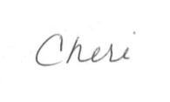
Cheri Plattner
Director, Speedway Children’s Charities – Sonoma Raceway
707-933-3950 cplattner@sonomaraceway.com

