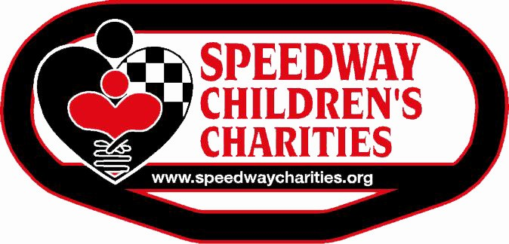

Dear Applicant:

Thank you for your interest in Speedway Children’s Charities regarding funding for your project. As you may know, we are a foundation dedicated to helping children. We produce and coordinate various events throughout the year to raise funds to distribute to worthy children’s organizations; therefore, it is our pleasure to offer you the 2020 Charlotte Speedway Children’s Charities Grant Application.

Due to the increasing volume of grant applications, we are continuing with a two-round approach with a greater focus on meeting the critical needs of children in our community. Organizations who meet the criteria outlined in the grant application are invited to submit a brief summarized application (4 pages) describing your program and funding needs.

It is our desire to meet the physical, medical, educational, and social needs of all children. You are eligible to apply for funding from Speedway Children’s Charities if you are an existing 501(c)(3) non-profit charity for a minimum of one year, whose primary focus is children. We serve the counties of Cabarrus, Gaston, Iredell, Mecklenburg, Rowan, Stanly, Union in North Carolina and Chester, Lancaster, Union and York in South Carolina.

Speedway Children’s Charities will consider one grant request per federal Tax ID number each year. If your non-profit has more than one organization functioning under the same Tax ID number, we ask that you select one organization to apply for funding.

The Round One Application must be received by the deadline of 5:00p.m. June 2, 2020. Absolutely no exceptions will be made. Applications will not be accepted via fax, or email. You may reproduce the document as long as all questions are answered in the order originally presented.

The Speedway Children’s Charities Board of Trustees will convene to evaluate Round One requests in June. Those advancing to Round Two will be invited to submit a more detailed application for final consideration.

Best Wishes,

Lisa Starnes
Executive Director of Charlotte Chapter
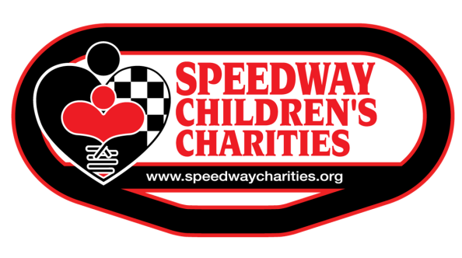

Grant Eligibility

Please review the following eligibility requirements before submitting your application. If your organization does not meet the following eligibility requirements, your application cannot be approved.

- Organization must be established as a 501(c) (3) for a minimum of one year.
- Projects must serve the needs of children in critical, financial, medical, educational or social needs.
- First year applicant’s maximum request cannot exceed $4,000.
- Organizations must serve children in the following counties: Mecklenburg, Cabarrus, Gaston, Iredell, Union, Stanly or Rowan in NC and York, Chester, Lancaster or Union in SC.
- Capital projects or office supplies are ineligible for funding.
- Grants for purchase of vehicles will be ineligible.
- Funding cannot be used for salaries, consulting fees or scholarship programs.

Round One applications must be received at the following address no later than 5 p.m. on June 2, 2020.

Speedway Children’s Charities
Attn. Samantha Filcik

5555 Concord Parkway S.
Concord, NC 28027
704-455-4426

Applications submitted via email or received after the deadline will not be considered for funding

Charlotte Chapter

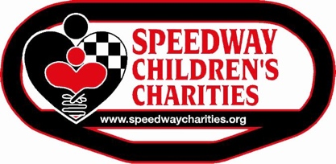
2020 Grant Application

Date of Application: |  |  |  | / / |  |  |  |  | Tax ID: |  |  |  | - |  |  |  |  |  |  | Year founded locally:
Legal name of organization applying:
(should be same as on IRS determination letter)
Executive Director: |  |  |  |  |  |  |  |  |  |  |  |  |  |  |  |  | Phone number: |  |  |  |  | ( )
Email:
Program Coordinator/Contact Person: |  |  |  |  |  |  |  |  |  |  |  |  |  |  |  |  |  | Phone number: |  |  |  |  | ( )
(if different from executive director)
Email:
Address (main local office):
City: |  |  |  |  |  |  |  |  | State: |  |  |  |  | Zip:
Website: |  |  |  |  |  |  |  |  |  |  |  |  |  | Email:
Past SCC Grant Recipient?  Yes No |  |  |  |  |  |  |  |  |  |  | If yes, amount of past grant and year received, beginning with most recent:
Amount |  | Year |  |  |  | Amount |  |  |  | Year |  |  |  |  | Amount |  |  |  | Year |  | Amount |  |  |  | Year
$ |  |  |  |  |  | $ |  |  |  |  |  |  |  |  | $ |  |  |  |  |  | $
Select the type of Grant that best describes your program (select only ONE):

Critical(food, clothing, shelter) Medical Educational Social

Grant Amount Requested $_______________Number of Children Served Yearly __________

Provide short one-sentence description of your project: ______________________________

______________________________________________________________________________

Project Narrative (must directly affect the needs of children)
Provide a brief description of the proposed project in the space provided. Include the goals of the project and the number of children served by this project each year. Please limit to space provided
Qualifications of Project Proposal

Provide a brief summary of the qualifications of the individuals who will be responsible for implementing the project. Please limit to space provided

Program Duration:
If your project is long term, please explain your plans for funding.
(grants, state or federal support, fundraisers, etc…) Please limit to space provided

Description of Applicant Organization
Include date organized, scope of services, programs, number of people served, number of children receiving services, priorities, and plans. Please limit to space provided

Geographical areas served: (check all that apply) | Cabarrus Gaston Iredell Mecklenburg Rowan, NC  Stanly Chester Lancaster Union, NC Union, SC York
What is the demographic of the population of the children served in this program?

% Caucasian % African American % Hispanic % Asian % Other
AGENCY BUDGET
Budget Fiscal Year
Agency: (enter agency name here)
Program Support/Revenue | 2021 Proposed | 2020 Budget | 2019 Actual
1. Annual commitment from United Way
2. Funds from Speedway Children's Charities
3. Contributions from Individuals
4. Contributions from Corporations/Foundation
5. Endowments/Restricted Contributions
6. Special Events/Fundraising Events
7. Governmental Grants/Fees
8. Program Service Fees/Revenues/Dues
9. Investment/Interest Income
10. Income from Other Sources (specify)
A.
B.
C.
D.
11. TOTAL PROGRAM REVENUE
Program Expenses/Costs | 2021 Proposed | 2020 Budget | 2019 Actual
12. Salaries/Wages
13. Employee Benefits/Taxes
14. Professional Fees
15. Supplies
16. Telephone
17. Postage/Shipping
18. Occupancy
19. Insurance Taxes
20. Equipment Rental/Repair/Maintenance
21. Printing/Publications
22. Travel/Staff/Volunteer Training
23. Organization Dues
24. Fundraising/Volunteer Recognition
25. Direct Assistance to Clients
26. Miscellaneous (specify)
A.
B.
C.
D.
27. TOTAL PROGRAM EXPENSES/COSTS
IMPORTANT: THIS BUDGET WORKSHEET MUST BE COMPLETED BY YOUR AGENCY! THIS IS FOR THE AGENCY NOT THE PROJECT

Certification
We certify that the information contained in this application, including all attachments, is true and correct to the best of our knowledge.

_________________________________ __________________________
Signature, President of Board of Directors/ Signature, Project Coordinator
Authorizing Official

____________________________ ____________________________

____________________________ ____________________________

____________________________ ____________________________

____________________________ ____________________________

Type name, position and address of Type name, position and address of
above person. above person.

Round One applications must be received at the following address no later than 5 p.m. on June 2, 2020.

Speedway Children’s Charities
Attn. Samantha Filcik

5555 Concord Parkway S.
Concord, NC 28027
704-455-4426

Applications submitted via email or received after the deadline will not be considered for funding

For questions please e-mail sfilcik@speedwaycharities.org

