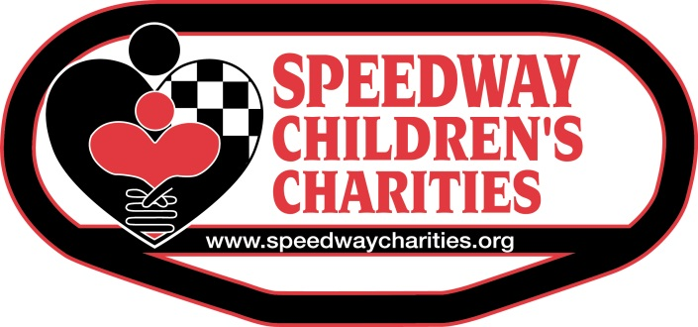

Dear 2018 Partner Grant Applicant:

The Las Vegas Chapter of Speedway Children’s Charities provides funds to organizations that meet the needs of children throughout Southern Nevada. We can best affect children’s lives by supporting organizations that work tirelessly to see that children’s needs are met and that no child is left behind regardless of illness, social environment or disability.

To apply for a grant, an applicant organization must meet the following requirements:
- Services provided to children in Southern Nevada who fall within the mission of Speedway Children’s Charities: educational, financial, social and/or medical need
- Be a 501(c)(3) non-profit entity with one full year of operations supported by financial documents

Partner Grant Applications must be delivered or postmarked by Friday, August 31, 2018.
Partner Grant Applications will not be accepted electronically (fax or email).

  - Partner Grant requests must be for a specific project that directly affects the needs of children (simply stating it is in support of a children’s program does not qualify)
  - First-year approvals for grants cannot exceed $1,000
  - No grant requests over $10,000 will be accepted (and maximum funding based on available funds)
  - Grants could be limited for organizations with total revenues that exceed one million
  - Grants could be denied or limited based upon public information of questionable moral turpitude concerning practices of the organization, the board members or employees such as convictions or arrests involving fraud, theft, embezzlement, any vehicle crime, sexual offenses or violent crimes against a person

  - The following grant requests will not be accepted:
    - Capital funding projects (construction of buildings or remodeling), or fixed assets, like purchase of vehicles
    - Funding for salaries or consulting fees, marketing, purchase of office supplies, seminar materials, or scholarship programs
    - Development or production of books, films, videos or television programs
    - Sponsorships, like conferences, events, golf tournaments
    - Organizations that deny service to a potential client or beneficiary on the basis of race, religion, color, sex, sexual orientation, age or national origin
    - Individual schools in public school systems unless benefits are system-wide
    - Religious organizations unless specific project is nonsectarian and benefits community

Speedway Children’s Charities will consider one Partner Grant request per Federal Tax ID number each year. If your non-profit has more than one organization functioning under the same Tax ID number, we ask you to select one organization to apply to Speedway Children’s Charities for funding of a Partner Grant.

Please supply all requested information and attach the proper documents. If ANY field of the application is left blank or any signature missing, your application will not be accepted. To be considered for review, a complete Partner Grant Application MUST include two (2) copies of EVERY document. Both complete copies of the Partner Grant Application must be collated, and each secured with one paper clip or binding clip. You may reproduce this application, but you must answer the questions in the order and form in which they are requested. Please ensure both copies are signed by two parties in both places.

Determinations will be made by our Board of Trustees in November, and you will be notified in writing by the end of that month. Grants are distributed at the beginning of December at our Tree Lighting Ceremony at Las Vegas Motor Speedway. Due to the large volume of requests, Speedway Children’s Charities is unable to grant every proposal. Applicants should understand that rejection of a proposal in no way suggests rejection of the organization.

The applicant should retain a copy of the application for their files. Charities who are awarded grants should not consider these funds as part of their annual budget.

Thank you again for your interest in Speedway Children’s Charities. Feel free to contact the Las Vegas Chapter Director, Paulette Anderson, with questions at (702) 632-8242 or panderson@lvms.com.

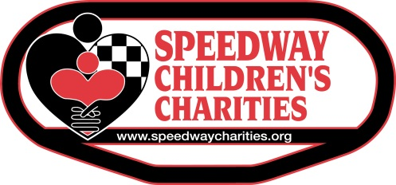

PARTNER GRANT APPLICATION

CHECKLIST

Completed Partner Grant Applications to Speedway Children’s Charities MUST include two (2) copies of EVERY document to be considered for review. Two complete and signed copies of the Partner Grant Application must be collated, and each secured with one paper clip or binding clip.

All Partner Grant Applications must be completed and delivered or postmarked on or before August 31, 2018. Partner Grant Applications must be completed in their entirety to be accepted.

To ensure your application is complete, please check every item listed below before submitting!

PARTNER GRANT APPLICATION CHECKLIST
☐2 Copies of Cover Letter from Board President
☐2 Speedway Children’s Charities Partner Grant Application Cover Sheets
☐2 Speedway Children’s Charities Partner Grant Applications
☐2 Copies IRS 501 (c) (3) Verification
☐2 Copies of Organization Financial Documents and Tax Return
☐2 Copies of your Board of Directors - each on a separate sheet of paper
☐2 Copies of your Mission Statement - each on a separate sheet of paper
☐2 Copies of your Organizational Chart - each on a separate sheet of paper

**Please note: Do not include marketing materials and please no front-and-back printing. No staples please.

The Partner Grant Application must be completed using our standard 2018 form; no changes should be made to the structure of this form.
Please answer all questions in the space provided and sign in all requested spaces. You may include attachments as a supplement to your answer. Do not use the attachments as the answer.

Please mail grant application to:
Speedway Children's Charities
7000 Las Vegas Boulevard North
Las Vegas, NV 89115

Attention: Paulette Anderson, Las Vegas Chapter Director

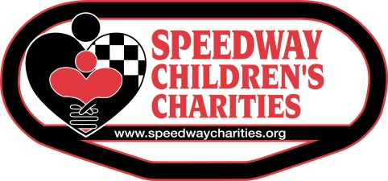

2018 PARTNER GRANT APPLICATION COVER SHEET

Date of Application: ___________ Tax ID: ___________________________ Year founded: ___________
Legal Name of Organization: ________________________________________________________________
(Should be same as on IRS determination letter and as supplied on IRS Form 990)
Executive Director: _________________________________ Phone number: ________________________
Contact person/title/phone number (if different from Executive Director): ____________________________________________________________________________________________
Address (principal/administrative office): _____________________________________________________
City/State/Zip: ______________________________________________________________________________
Fax Number: ______________________ E-mail Address: _______________________________________
List any previous grants received from SCC in the last 3 years:
2017: _____________________
2016: _____________________
2015: _____________________
Current Operating/Program Budget Percentages:
________% of Operating Budget for Admin/Fundraising
________% of Operating Budget serving children & youth
________% of Operating Budget for this Project
Geographic Area Served (please list specific county or community): _________________________
Project Name: ___________________________________________________________________________
Select Mission Fulfilled: ___ Education ___ Financial ___ Social ___ Medical
Purpose of Grant (one sentence): ________________________________________________________
_________________________________________________________________________________________
_________________________________________________________________________________________
_________________________________________________________________________________________
Planned Project Start Date: ______________ Planned Completion Date: ____________________ Amount Requested: $________________________ Total Project Cost: $______________________
# Children Who Will Benefit from this Project _____________

___________________________/__________/________________________/__________/
Signature, Chairperson, Board of Directors Date Signature, Executive Director Date

2018 PARTNER GRANT APPLICATION

Mission Statement: The mission of SCC remains true to the ideals it was founded upon in 1982: To care for children in educational, financial, social and medical need in order to help them lead productive lives.

SCC provides funding for hundreds of non-profit organizations throughout the nation that meet the direct needs of children.

NARRATIVE

Please type the information requested under each section/subsection in standard-size font.

1. Description of Applicant Organization:
Include history, mission and goals. Describe current programs, activities and accomplishments. Please include the responsibilities of the board, staff and volunteers.

2. Purpose of Grant:
a. Describe needs/problems to be addressed, target population and how they will benefit.

b. Describe project goals, measurable objectives, action plans and whether this is a new or ongoing part of your organization.

c. Describe similar existing projects or agencies, if any, and explain how your agency or proposal differs.

3. Qualifications of Project Personnel:
Describe the qualifications of key staff and volunteers that will ensure the success of the program.

4. Evaluation:
a. Who will be responsible for evaluating the program?

b. How will success be defined and measured?

5. Program Duration:
If this will be an ongoing program, please include the long-term strategies for funding this project at the end of the grant period.

6. Further Clarification of Tax Return Data:

Does your organization pay more than 50% of Total Revenues for Salaries? If so, please explain how the salaries paid directly contribute to your programing and touch the lives of children you serve:

7. Fiscal Information of Applicant Organization:

On a separate page show how each budget item relates to the project and how the amount budgeted was calculated.

Annual Operating Budget
______ Last Year (2017)
______ Present Year (2018)
______ Next Year Budget (if available) (2019)

Project Budget
______ Present Year, if applicable (2018)
______ Next Year (2019), Complete the project budget that follows.

8. Has your organization received Speedway Children’s Charities funding in the past? If yes, complete section 8.

The last year your organization received funding from SCC: _____________

Amount of last grant: $_______________

Provide a brief narrative of how Speedway Children’s Charities funding affected your project. Include the short-term changes you have observed and the long-term goals you are still working to achieve.

9. Certification:
We certify that the information contained in this application, including all attachments are true and correct to the best of our knowledge.

__________________________________________ ________________________________________
Signature, Chairperson, Board of Directors Signature, Executive Director/Project Coordinator

____________________________ ___________________________

____________________________ ___________________________

____________________________ ___________________________

____________________________ ___________________________

Type name, position and address of Type name, position and address of
above person above person

PROJECT BUDGET—CURRENT REQUEST
PROJECT INCOME |  | Amount Committed | Amount Pending*

Support
Government grants |  | $Click here to enter text. | $Click here to enter text.
Foundations |  | $Click here to enter text. | $Click here to enter text.
Corporations |  | $Click here to enter text. | $Click here to enter text.
United Way or federated campaigns |  | $Click here to enter text. | $Click here to enter text.
Individual contributions |  | $Click here to enter text. | $Click here to enter text.
Fundraising events and products |  | $Click here to enter text. | $Click here to enter text.
Membership income |  | $Click here to enter text. | $Click here to enter text.
In-kind support |  | $Click here to enter text. | $Click here to enter text.
Investment income |  | $Click here to enter text. | $Click here to enter text.
Speedway Children’s Charities |  | $Click here to enter text. | $Click here to enter text.

Revenue
Government contracts |  | $Click here to enter text. | $Click here to enter text.
Earned income |  | $Click here to enter text. | $Click here to enter text.
Other (specify) |  | $Click here to enter text. | $Click here to enter text.
Click here to enter text. |  | $Click here to enter text. | $Click here to enter text.
Click here to enter text. |  | $Click here to enter text. | $Click here to enter text.
Total Income |  | $Click here to enter text. | $Click here to enter text.
*Note: Pending sources of support include those requests currently under consideration. Please indicate anticipated date.

PROJECT EXPENSES
Item |  | Amount | $ SCC Funds
Salaries and wages |  | $Click here to enter text. | N/A
Click here to enter text. |  | $Click here to enter text. | $Click here to enter text.
Click here to enter text. |  | $Click here to enter text. | $Click here to enter text.
Click here to enter text. |  | $Click here to enter text. | $Click here to enter text.
SUBTOTAL |  | $Click here to enter text. | $Click here to enter text.
Insurance, benefits and other related taxes |  | $Click here to enter text. | N/A
Consultants and professional fees |  | $Click here to enter text. | N/A
Travel |  | $Click here to enter text. | N/A
Equipment |  | $Click here to enter text. | N/A
Supplies |  | $Click here to enter text. | $Click here to enter text.
Printing and copying |  | $Click here to enter text. | N/A
Telephone and fax |  | $Click here to enter text. | N/A
Postage and delivery |  | $Click here to enter text. | N/A
Rent and utilities |  | $Click here to enter text. | N/A
In-kind expenses |  | $Click here to enter text. | N/A
Depreciation |  | $Click here to enter text. | N/A
Other (specify) |  | $Click here to enter text. | $Click here to enter text.

Total Expense
DIFFERENCE (Income less Expense) |  | $Click here to enter text. | $Click here to enter text.

