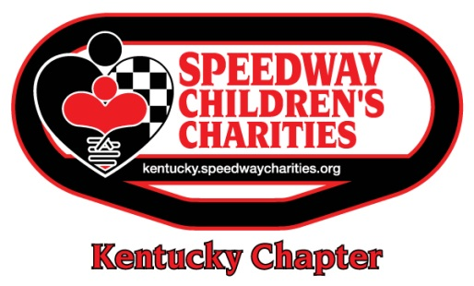

2018 SCC CHARITY CLAY SHOOT
FUNDRAISING GOAL: $46,700
This document summarizes the opportunities the Kentucky Chapter has available for its 2018 Charity Clay Shoot.
All sponsorships are exclusive and are first-come, first-served.

6TH ANNUAL PULLING FOR KIDS CHARITY CLAY SHOOT  PRESENTED BY THE NRA FOUNDATION  THURSDAY, JULY 12, 2018  SPONSORSHIP OPPORTUNITIES | SHOTGUN - $7,500 | TARGET - $6,000 | GIFT BAG -  $4,500 | GOLF CART - $3,500 | AMMO - $3,500 | BEVERAGE - $2,000 | AWARDS - $2,000
*Recognition in all press releases, promotional materials and social media announcements | X | X
Team of four (4) participants | 2 | 1 | 1 | 1 | 1 | 1 | 1
Bluegrass Club tickets and parking for the NASCAR Truck Series race on Thursday, July 12 | 4 | 4 | 2
Grandstand tickets for the NASCAR Truck Series race on Thursday, July 12 |  |  |  | 4 | 4
All clay shoot sponsorship packages include sponsorship level exclusivity, recognition by the host during the event and your sponsor logo on Kentucky’s website sponsor page for one year, SCC’s page in Kentucky Speedway’s July 2018 race program and signage at your team’s starting course station.

*For all sponsorships, company must meet copy deadlines to be included in promotional materials, programs, signage, etc.

CLAY SHOOT TEAM REGISTRATION
$1,650 for each team of four (4) participants – Deadline: Friday, June 1, 2018
Includes shooting at 14 stations, meal, participant gift, golf cart & gun rentals, ear & eye protection, sporting clays, ammo and more

ADDITIONAL NOTES FOR SPONSORSHIPS AND DONATIONS
Proceeds from all fundraisers benefit the Kentucky Chapter of Speedway Children’s Charities and its Grant Distribution Program, which supports projects and programs that directly impact the lives of children in need. All funds raised remain in the local region.
Credit cards, debit cards and checks are acceptable forms of payment. Cash is also accepted in person at Kentucky Speedway during regular business hours. If paying by check, please make it payable to Speedway Children’s Charities, not Kentucky Speedway.
Contributions over the Fair Market Value (FMV) of each asset are tax-deductible. Applicable FMV’s for this event are:
- Shotgun Sponsor - $1,300 FMV
- Target Sponsor - $850 FMV
- Gift Bag Sponsor - $650 FMV
- Golf Cart Sponsor - $606 FMV
- Ammo Sponsor - $606 FMV
- Beverage Sponsor - $450 FMV
- Awards Sponsor - $450 FMV
- Team of Four Participants - $450 FMV

